FY 2013 Coca-Cola Summer Exchange Scholarship Program

Deadline for submitting applications: March 28th, 2013

The Coca-Cola Company, in partnership with the Indiana University Kelley School of Business Institute for International Business, is pleased to announce the Coca-Cola MENA Scholarship Program for 2013. For the second year, one hundred college-level students will be selected from eight countries across the Middle East, North Africa and near Asia to participate in a one month long, multi-faceted and immersive residential program at a leading US business school, in which they will learn best American business practices, refine their entrepreneurship skills, and develop the tools to create their own business plans. Students will be selected from Afghanistan, Algeria, Egypt, Jordan, Morocco, Pakistan, Palestinian Authority areas, and Tunisia.

- HISTORY

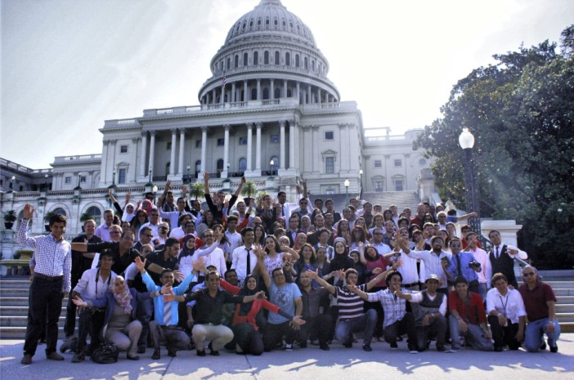
In 2011, The Coca-Cola Company successfully partnered with the United States Embassy in Cairo to send 10 Egyptian high school students to attend the Engineering Innovation Summer Program at Johns Hopkins University’s Whiting School of Engineering in Baltimore, Maryland. This program was part of The Company’s support of the U.S. Department of State’s Partners for a New Beginning (PNB), for which Muhtar Kent, Coca-Cola’s Chairman and CEO, serves as Vice Chairman. PNB is an alliance of public-private partnerships committed to deepening engagement between the United States and local communities on issues of education, exchange, economic opportunity, and science and technology, in order to advance the vision outlined by President Barack Obama in his 2009 Cairo Speech.
2012 Scholarship winners outside the United States Capitol Building in Washington, DC

In 2012 the Coca-Cola Company built upon the success of the 2011 Coca-Cola MENA Scholarship Program and partnered with Indiana University and once again with the United States Department of State. Together with the US Embassies in Rabat, Algiers, Tunis, Cairo, Amman, and the US Consulate in Jerusalem, the program expanded to include 100 college-level students who participated in a one month business course at Indiana University’s prestigious Kelley School of Business; they visited Washington DC – including a memorable afternoon at the State Department – and finished with a trip to the Coca-Cola Company’s headquarters in Atlanta.
"Indiana University's Kelley School of Business is pleased to collaborate in this program to bring up to 100 students from the Middle East & North Africa to Bloomington during the summer of 2012. As the premier entrepreneurship education institution, the Kelley School understands how critical entrepreneurship is to creating a flourishing economy. Small and medium-sized businesses are the motor for local economies around the world, and these future enterprises in North Africa and the Middle East will be built by the young university students who are inspired to become their own CEOs.”
Daniel C. Smith, President IU Foundation (former Dean, Kelley School of Business)

- IMPACT
While the immediate beneficiaries of the MENA Scholars’ program are the students themselves, the impact of this initiative is far-reaching:
- Creating Ambassadors: the winners, and indeed all the participants in the program, have proven to be excellent representatives, in the US for the youth of their country and in their home countries for the principles of ethical, entrepreneurial business. They are equipped to be the most effective advocates for the principles of the program today and the best hope for leadership tomorrow.
- Demonstrating the value of entrepreneurship: the winners are selected for the quality of their ideas and will be judged for real-world application; these ideas include practical solutions to solving hard social challenges as well as profit opportunities and the resulting case studies will inspire their peers and the next cohort.
- Generating media coverage: the 2012 Coca-Cola MENA Scholarship Program generated media buzz in local and regional media throughout the MENA region, across multiple channels – mainstream news sites; online news and business sites; blogs; and, of course, a massive following on Facebook. In 2013 we plan to increase the media presence by adoption of a major event in Atlanta, promoting the success of public-private partnership around entrepreneurship in the region.

- 2013 PROGRAM
The 100 Coca-Cola MENA Scholars for 2013 will be drawn from eight countries and territories - Afghanistan, Algeria, Egypt, Jordan, Morocco, Pakistan, Palestine, and Tunisia.

Program expansion and geographic composition
For 2013, the program will expand to include students from Pakistan and Afghanistan. Although not generally regarded as part of a traditional Middle East and North Africa region, these countries fall within the Coca-Cola MENA Business Unit. In common with the current participating countries, Afghanistan and Pakistan meet the criteria for inclusion in the program based on the demonstrated need to stimulate entrepreneurship and ethical business competencies within the countries; a youth cohort that is ready and willing to take responsibility for their country’s future; and where exposure to American culture will be extremely valuable in enhancing the US’s reputation and creating strong ambassadors for the future.

Application and selection
Please click on this link to submit your application: http://scholarship.coca-cola.com/website/
The Deadline for applications is: March 28th, 2013

Students will compete by first posting, online, an idea about how “to make tomorrow better” in their own country; the students whose ideas generate the greatest number of votes online will then be invited to submit a formal application. The Coca-Cola Company will review these formal applications and create a short list from which the 100 winners will be selected by the local US Embassies and the Consulate General in Jerusalem.

Residential program at Kelley School of Business, Indiana University
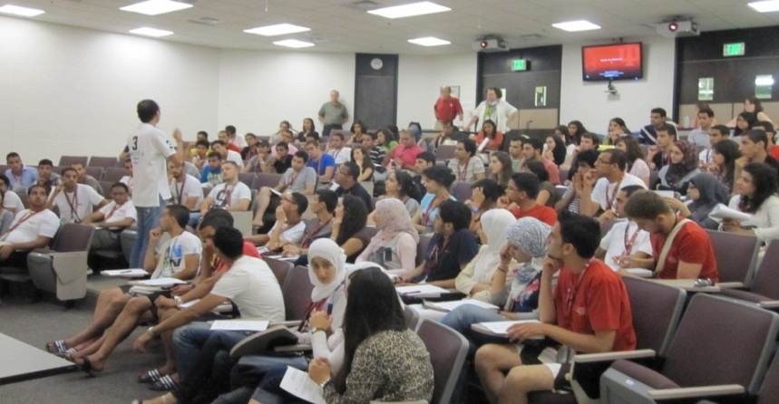
Scholarship winners will gain a basic understanding of American business practices through an accelerated 4-week curriculum based on the core elements of the Kelley School of Business undergraduate program, one of the top ranked programs in the United States. In order to encourage student engagement and participation, students will be divided into small groups of five during instructional portions of the program and each group will work with the same Kelley faculty members. Highlighted courses will include: Introduction to Business, Communications, Finance, Accounting, Marketing, Operations, Strategy, Human Resources, and Entrepreneurship. The Scholars will engage in a wide variety of instructional, interactive, and experiential sessions, in addition to group discussions, cultural and regional-specific talks, as well as the practical applications and implications of what they have learned in a variety of business settings.
Scholarship winners attending an introductory lecture for the 2012 MENA Scholars program

The Scholars will conclude their course with a formal presentation on their group project, in which they will present a practical feasibility study that could be implemented in their home country. An elite panel will judge the final presentations; this panel will be composed of faculty from the Kelley School of Business faculty, associates from The Coca-Cola Company, representatives of the US State Department, venture capitalists and private equity investors.

Exposure to business in the contest of American culture is an important goal of the program. Therefore, students will participate in field trips each week throughout the program; on these field trips the students will be able to interact with associates from local businesses and industry as well as government officials from the state of Indiana.

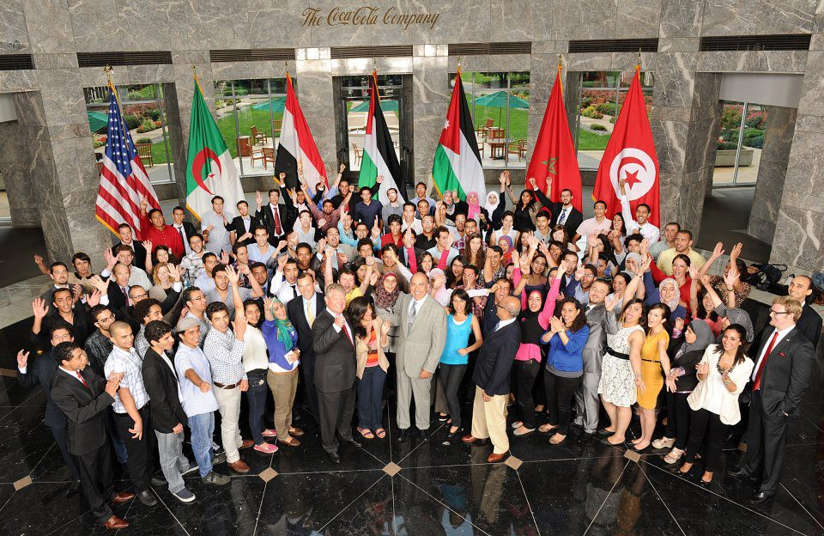
Muhtar Kent and MENA BU President Curt Ferguson with the Middle East and North Africa Coca-Cola Scholars at The Coca-Cola Company’s global headquarters in Atlanta.

About The Coca-Cola Company
The Coca-Cola Company is the world’s largest beverage company, refreshing consumers with nearly 500 sparkling and still brands. Along with Coca-Cola®, recognized as the world’s most valuable brand, the Company’s portfolio includes 12 other billion dollar brands, including Diet Coke®, Fanta®, Sprite®, Coca-Cola Zero®, vitaminwater®, POWERADE®, Minute Maid® and Georgia® Coffee. Globally, we are the No. 1 provider of sparkling beverages, juices and juice drinks and ready-to-drink teas and coffees. Through the world’s largest beverage distribution system, consumers in more than 200 countries enjoy the Company’s beverages at a rate of nearly 1.6 billion servings a day. With an enduring commitment to building sustainable communities, our Company is focused on initiatives that protect the environment, conserve resources and enhance the economic development of the communities where we operate. For more information about our Company, please visit our website at www.thecoca-colacompany.com.

About the Kelley School of Business at Indiana University
For 90 years -- first in Bloomington and later in Indianapolis -- IU's Kelley School of Business has prepared students to lead organizations, start companies, develop new products and services, and shape business knowledge and policy. Its programs are consistently ranked among the best in the nation, its faculty members are internationally recognized for their teaching and thought leadership and top businesses worldwide hire its highly qualified graduates. The Kelley School of Business offers undergraduate, MBA and specialized graduate, and Ph.D. programs. For more information, go to www.kelley.iu.edu.

